AdventureWorks Sales Analytics & Predictive Modeling
(SQL • Tableau • Machine Learning)

1. Introduction
This project focuses on end-to-end sales analytics and predictive modeling using the AdventureWorks dataset. It integrates SQL for data preparation, Tableau for visualization, and Machine Learning for predictive analytics.
In today’s data-driven business environment, organizations rely on analytics and machine learning to make informed decisions.
This project focuses on end-to-end sales analytics and predictive modeling using the AdventureWorks dataset.
The project is divided into three major parts:
- SQL – Data integration and preparation
- Tableau – Interactive dashboards and business insights
- Machine Learning – Predictive analytics (forecasting, churn, return risk)

2. Dataset Description
The dataset includes sales data from multiple years along with customers, products, categories, territories, and returns.The AdventureWorks dataset contains historical sales data across multiple years and dimensions.

Key Tables Used:
- sales_2015, sales_2016, sales_2017
- customers
- products
- product_categories
- product_subcategories
- returns
- territories
These datasets provide information about:
- Orders and quantities
- Customers and territories
- Products and categories
- Returns and profitability

3. SQL – Data Preparation & Integration

Objective:
To create a single unified sales view for analysis and visualization.

Key Steps:
- Combined yearly sales tables using UNION ALL
- Created a database view all_sales
- Ensured consistent schema across all years

SQL View Creation:
CREATE OR REPLACE VIEW all_sales AS
SELECT * FROM sales_2015
UNION ALL
SELECT * FROM sales_2016
UNION ALL
SELECT * FROM sales_2017;

Outcome:
- Centralized dataset
- Reduced duplication
- Ready for BI and ML use

📸 Screenshot Placement
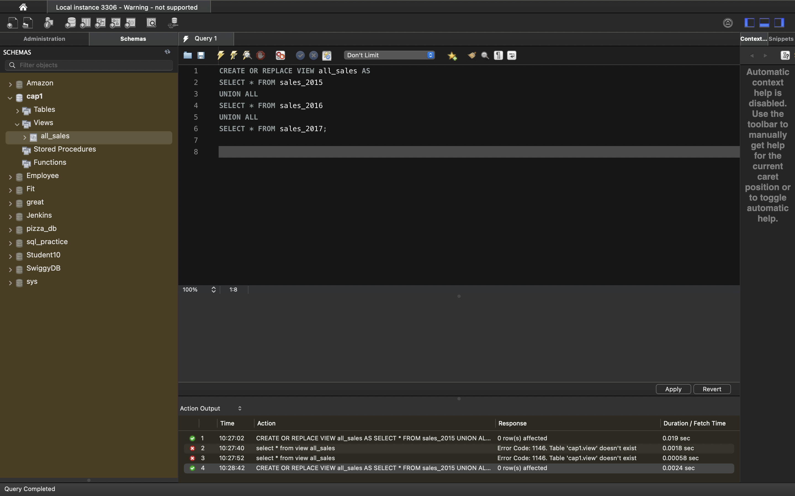
- Screenshot 1: SQL View Creation Query

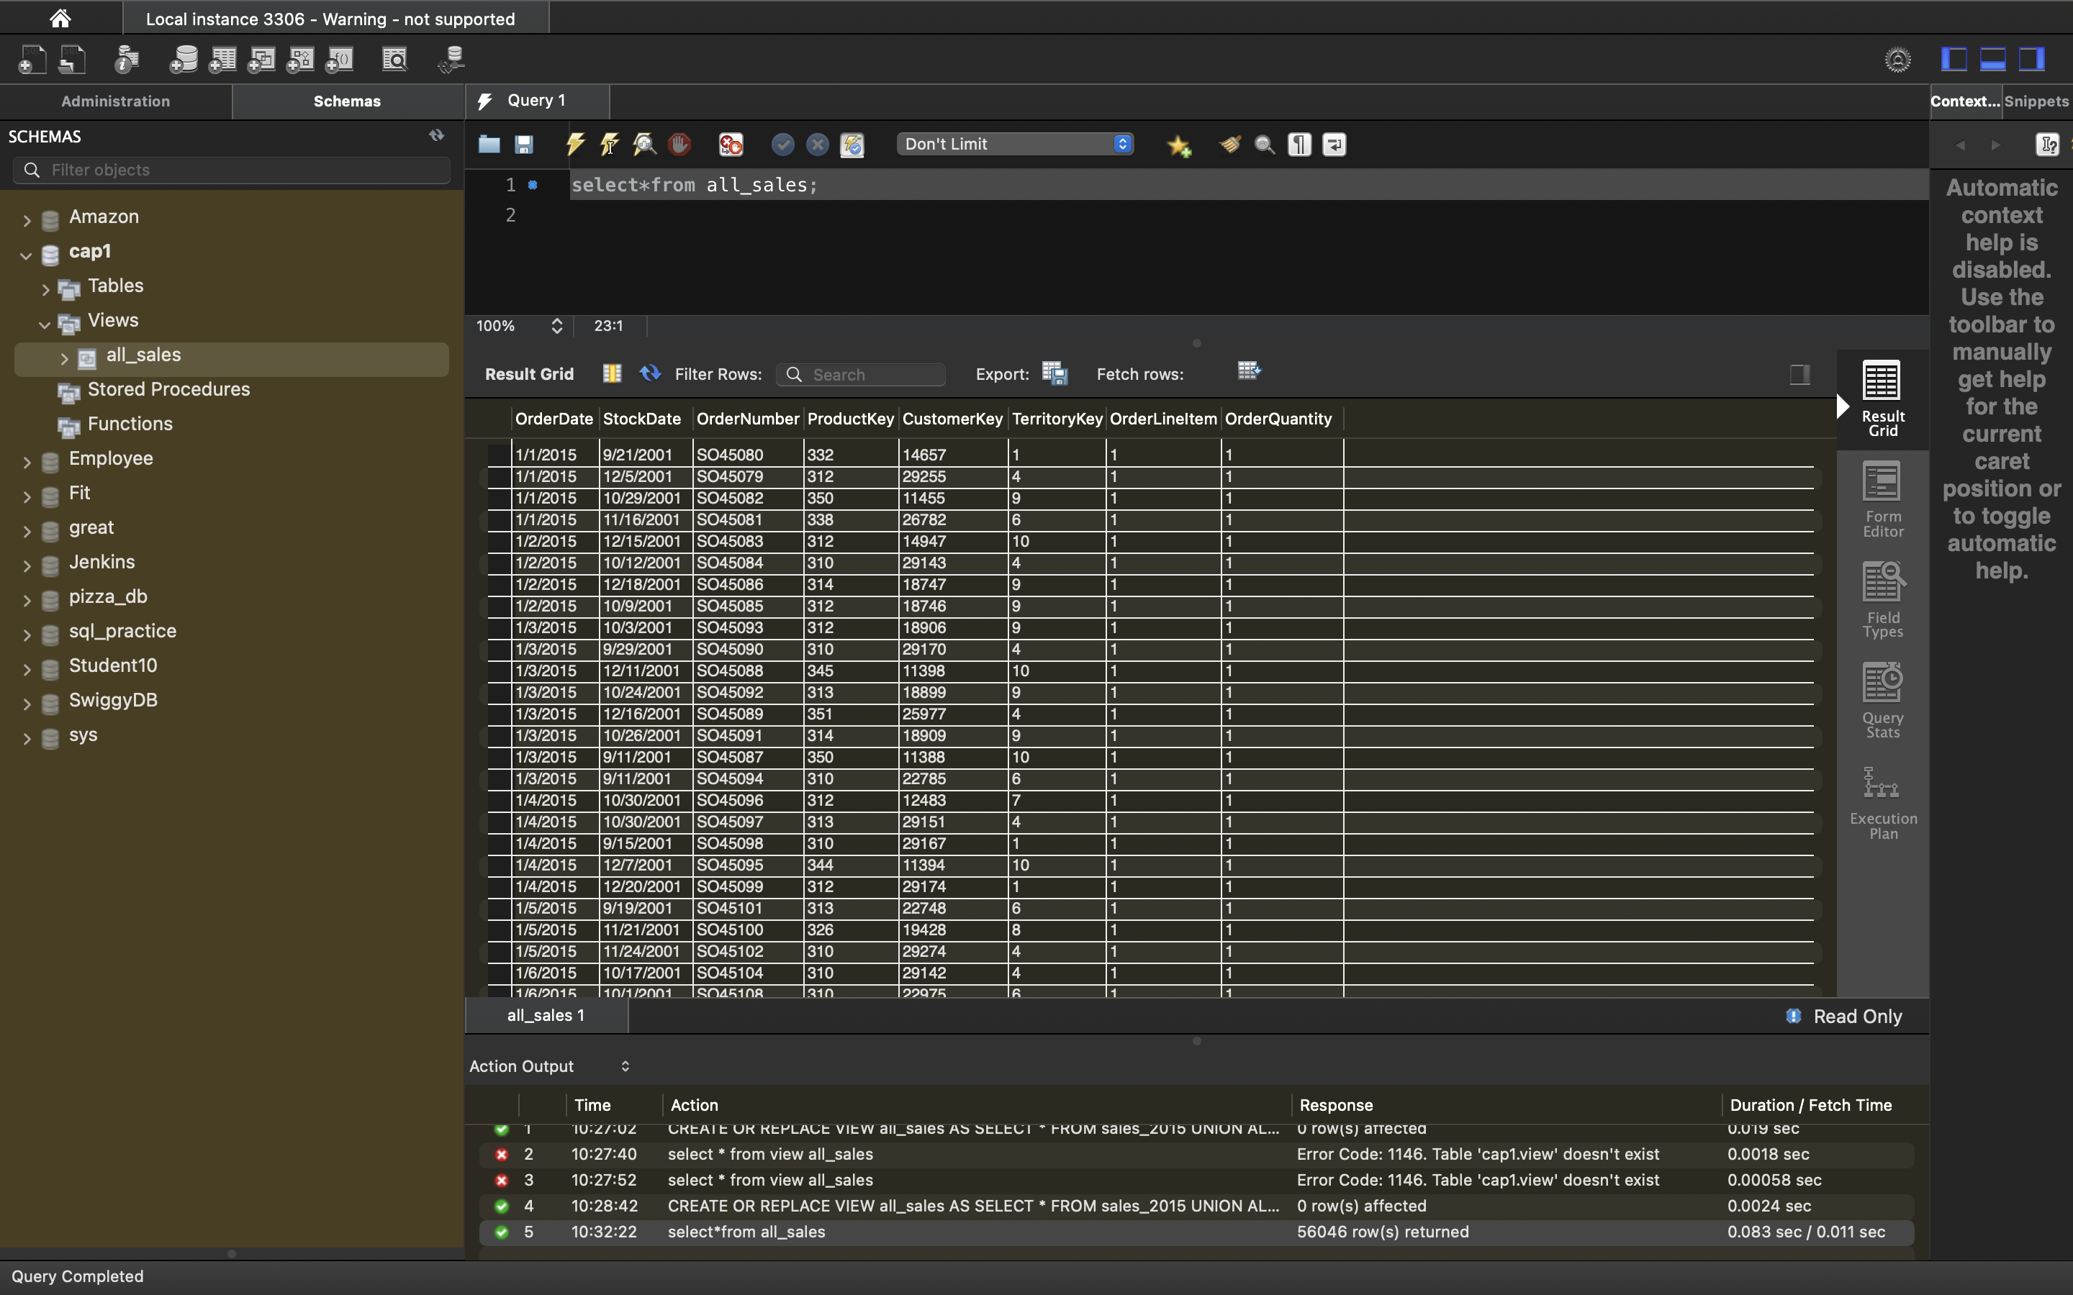
- Screenshot 2: Sample Output of SELECT * FROM all_sales

4. Tableau – Business Intelligence Dashboards
Dashboard 1: Revenue & Growth Overview

KPIs & Visuals:
- Total Revenue KPI
- Revenue Trend (Year-wise)
- Revenue by Product Category

Insights:
- Revenue increased significantly from 2015 to 2016
- Slight stabilization observed in 2017
- Bikes and Components are top revenue-generating categories
📸 Screenshot Placement
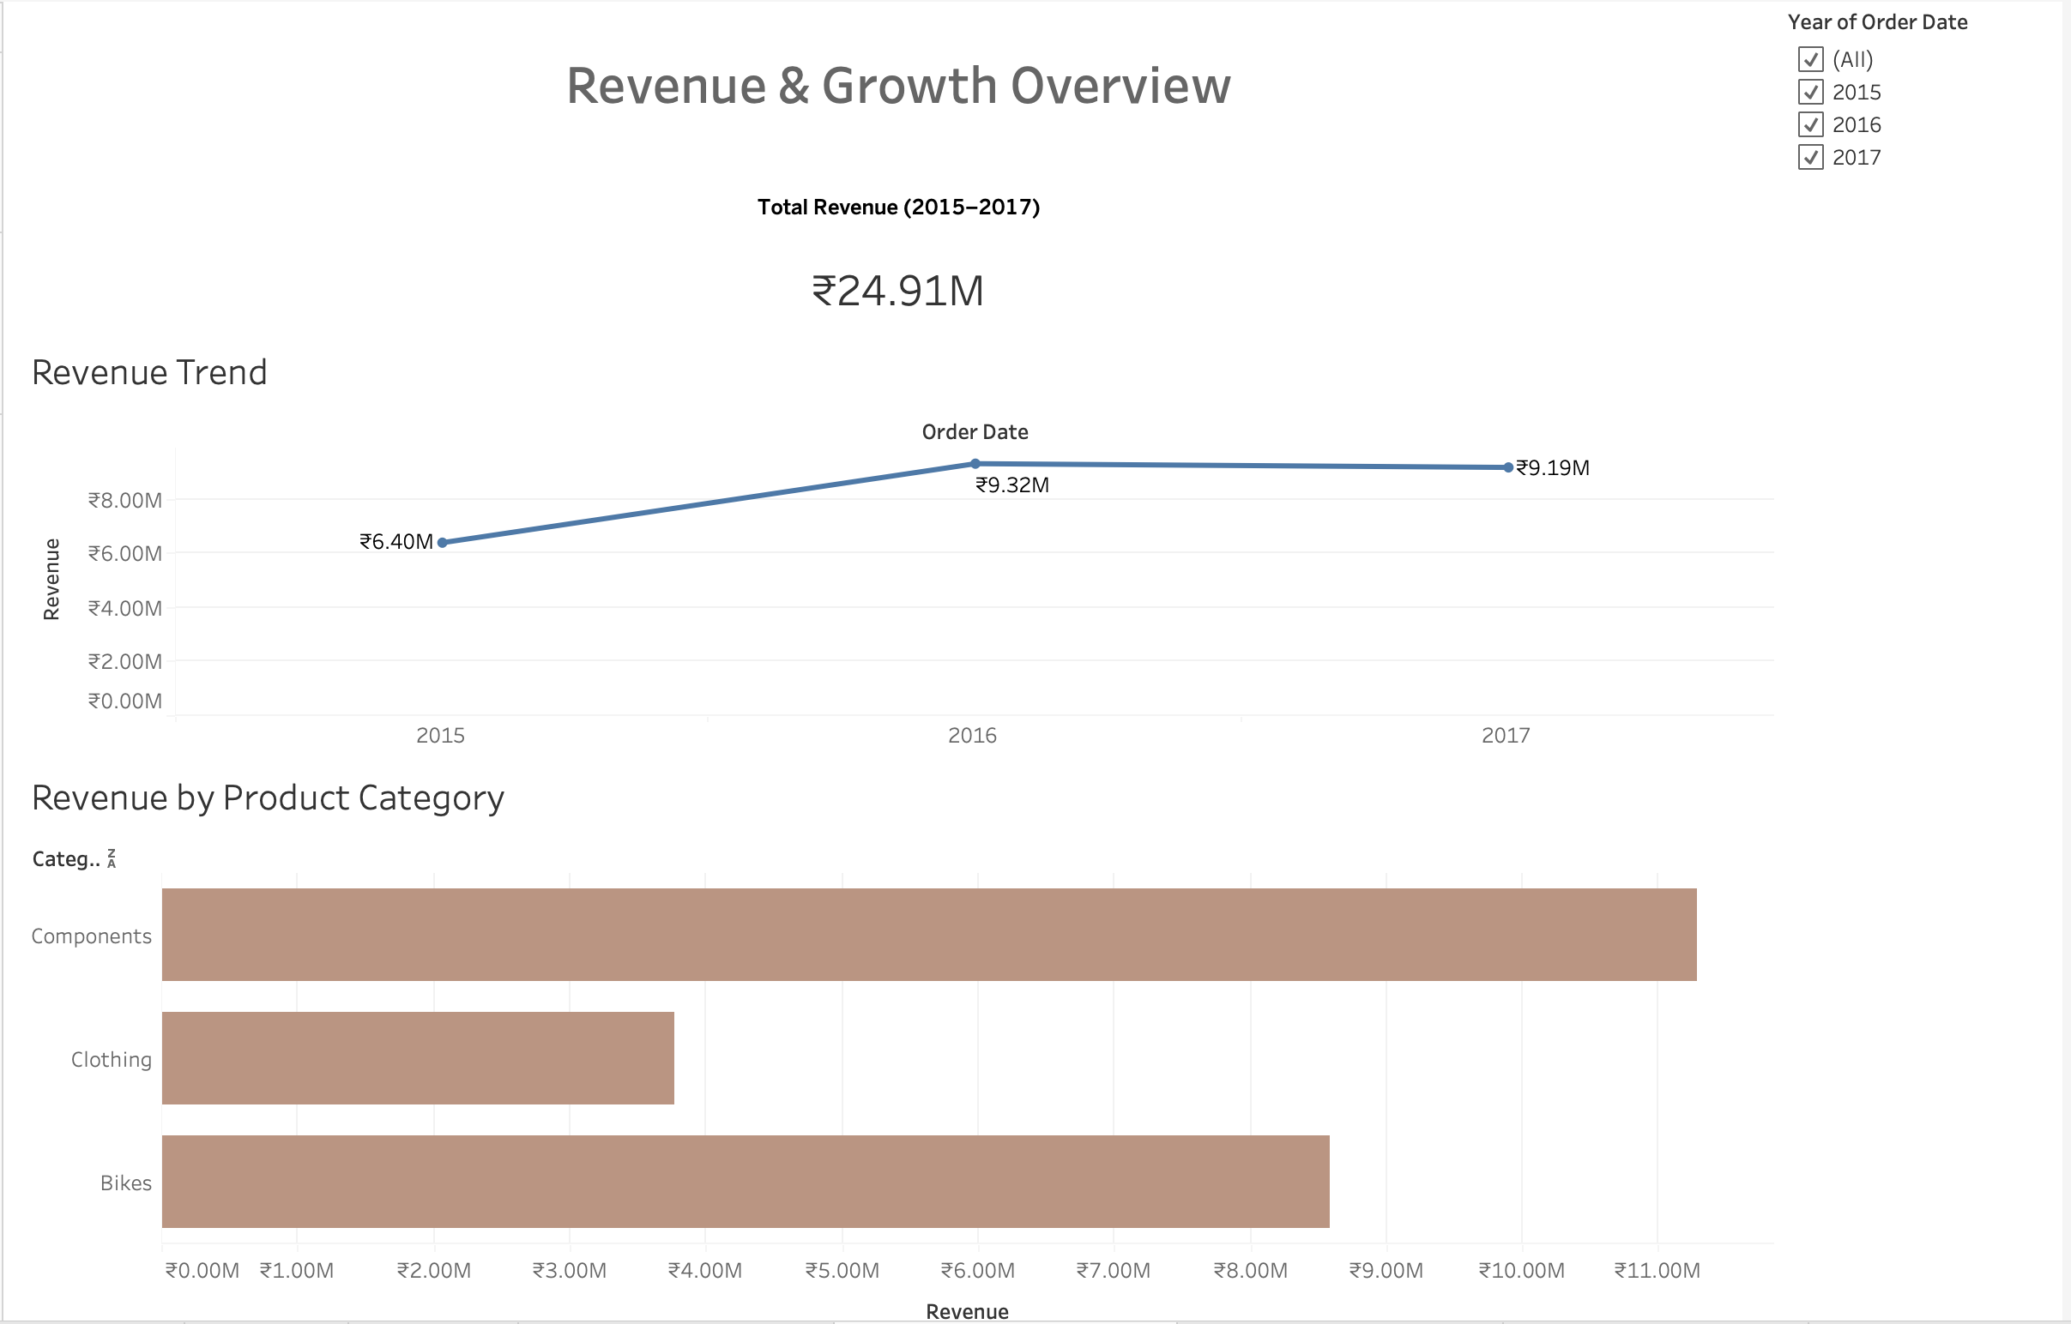
- Dashboard 1 – Revenue & Growth Overview
Dashboard 2 – Product & Category Insights

Visuals:
- Top Categories by Revenue
- Top 10 Products by Revenue
- Return Rate by Category

Insights:
- Certain products consistently outperform others
- Components show higher return rates compared to Clothing
- High-return products require quality or logistics review
📸 Screenshot Placement
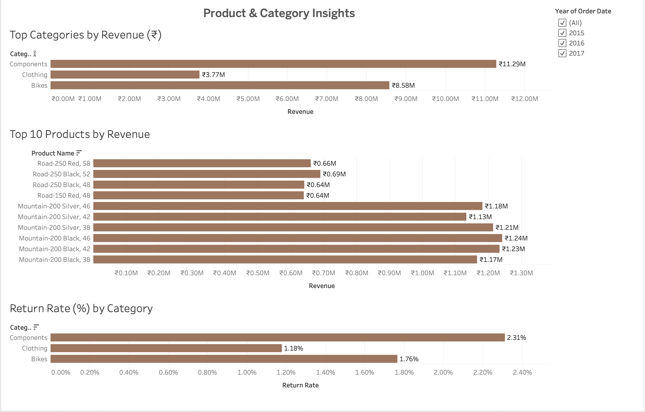
- Dashboard 2 – Product & Category Insights

Dashboard 3: Geographic Sales & Profitability

Visuals:
- Revenue by Country (Map)
- Top Regions by Revenue
- Profit Margin by Territory

Insights:
- North America contributes the highest revenue
- Some territories show high margins despite lower sales
- Profitability varies significantly by region
📸 Screenshot Placement

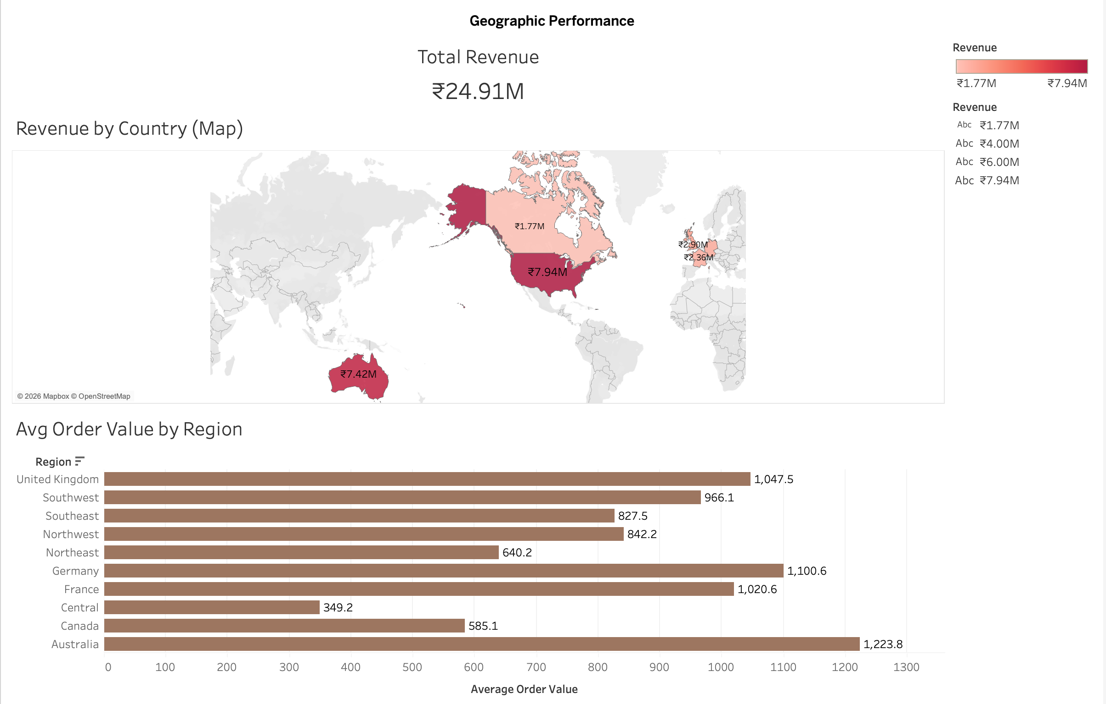
Dashboard 3 – Geographic Sales

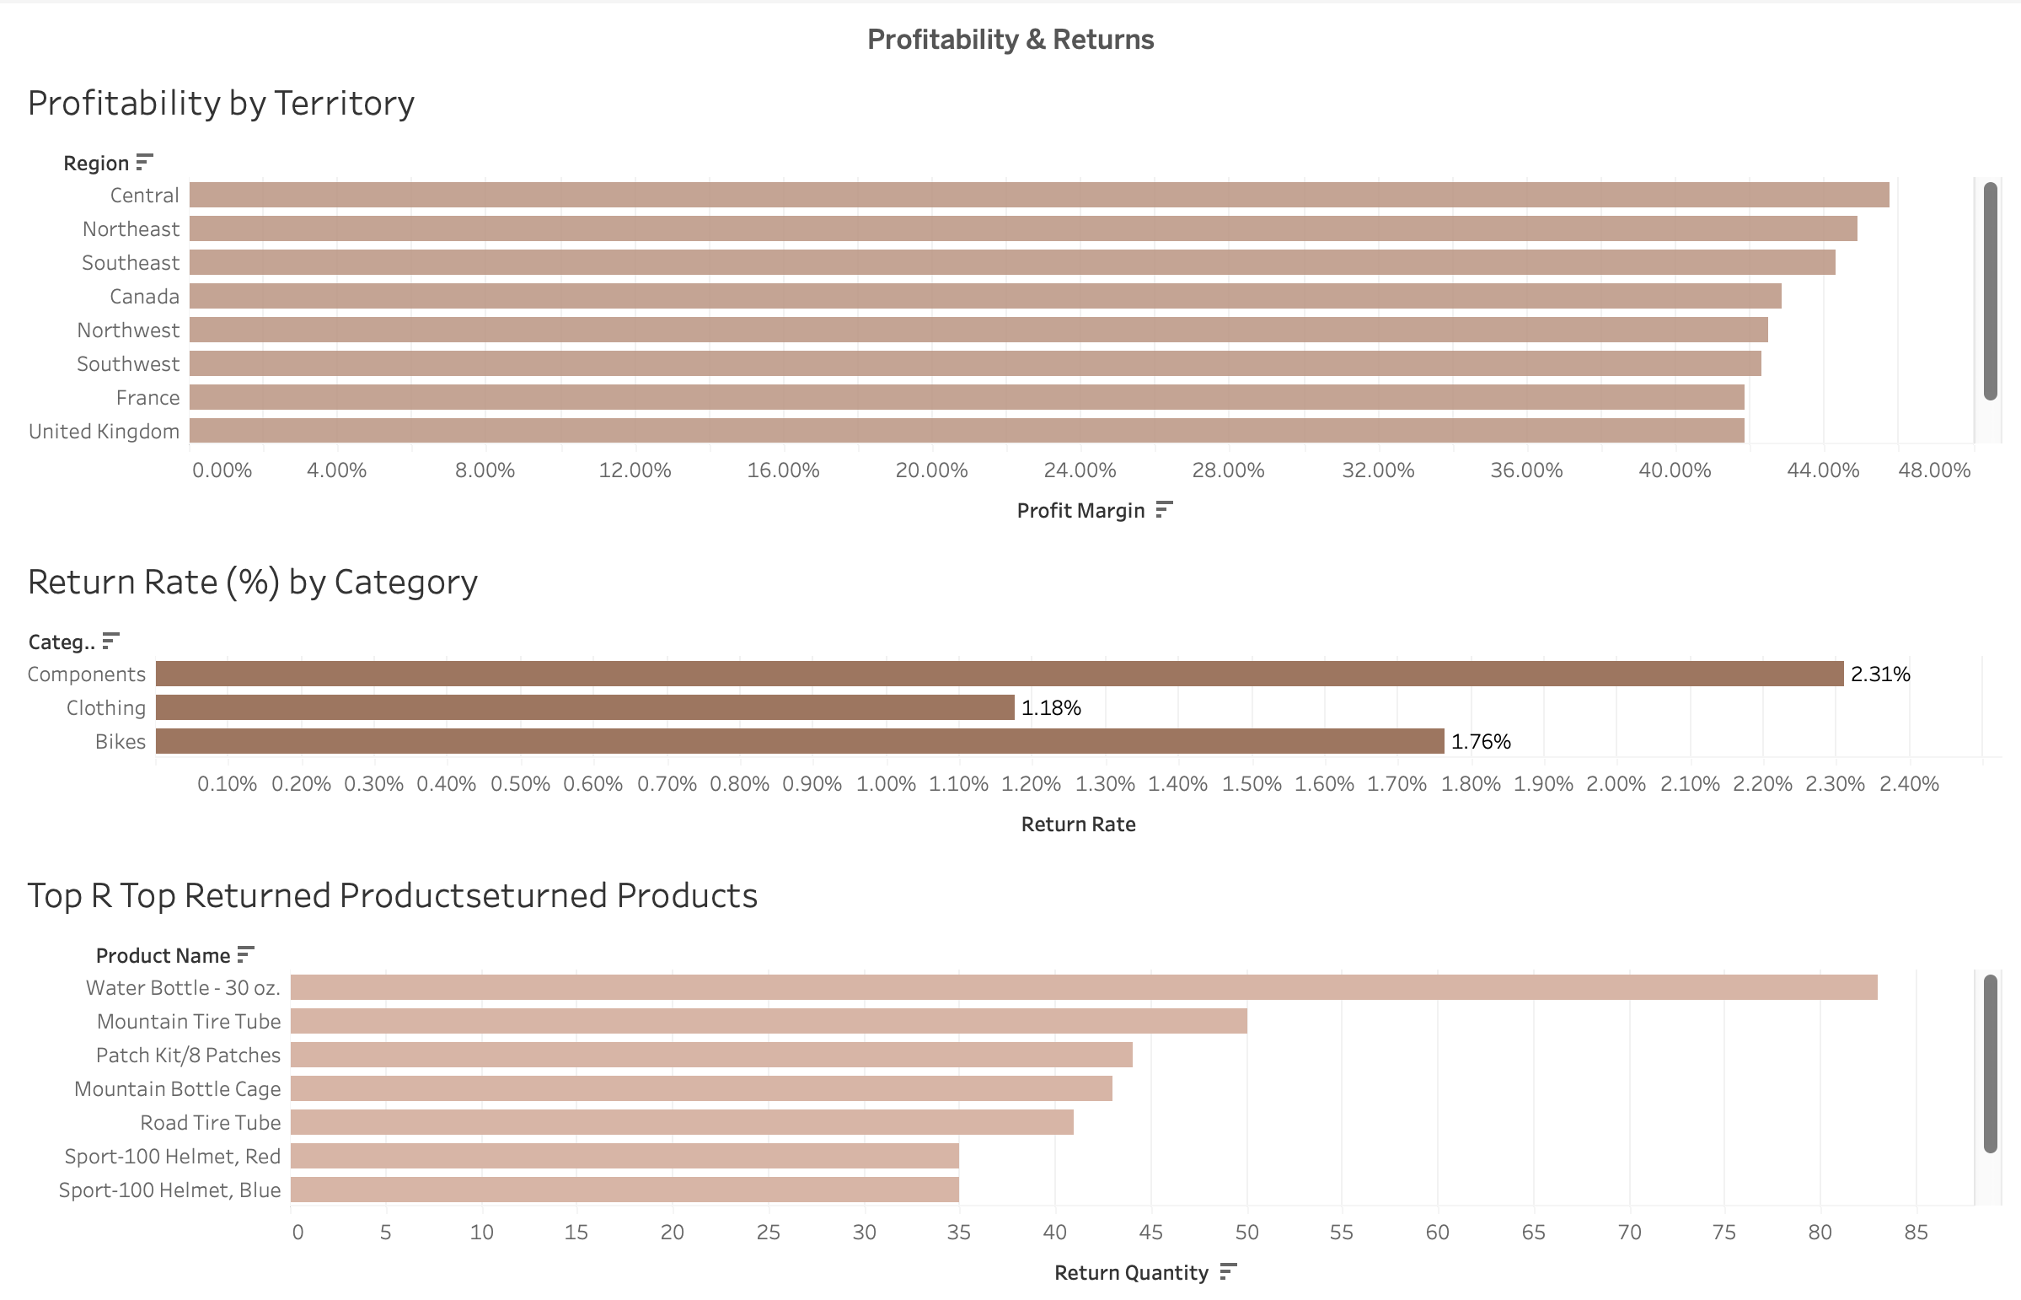
Dashboard4:Profitability
5. Machine Learning – Predictive Analytics
Revenue Forecasting:

Approach:
- Aggregated monthly revenue
- Used ARIMA (1,1,1) model from statsmodels

Output:
- Monthly revenue trend visualized
- ARIMA model summary generated

Business Value:
- Helps forecast next quarter revenue
- Supports budgeting and demand planning
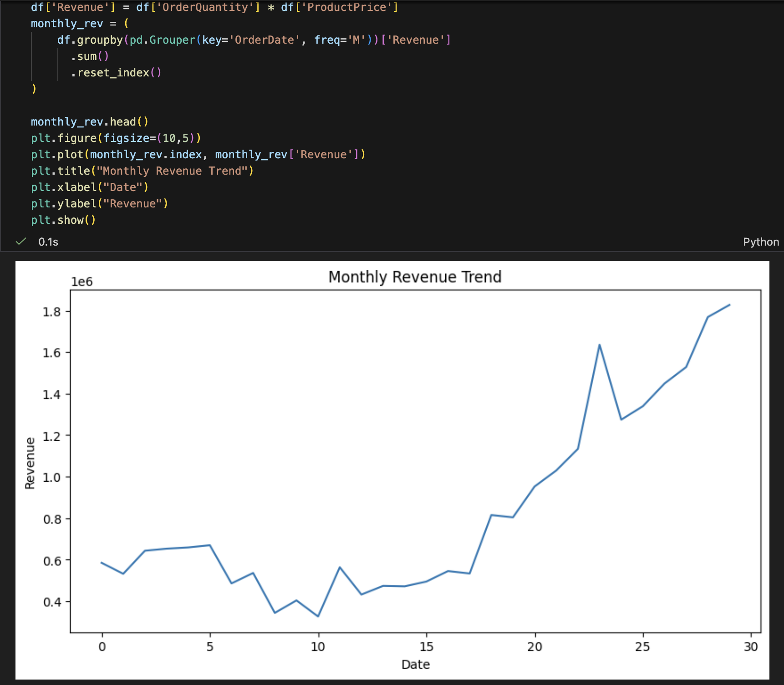
Monthly Revenue Trend Plot
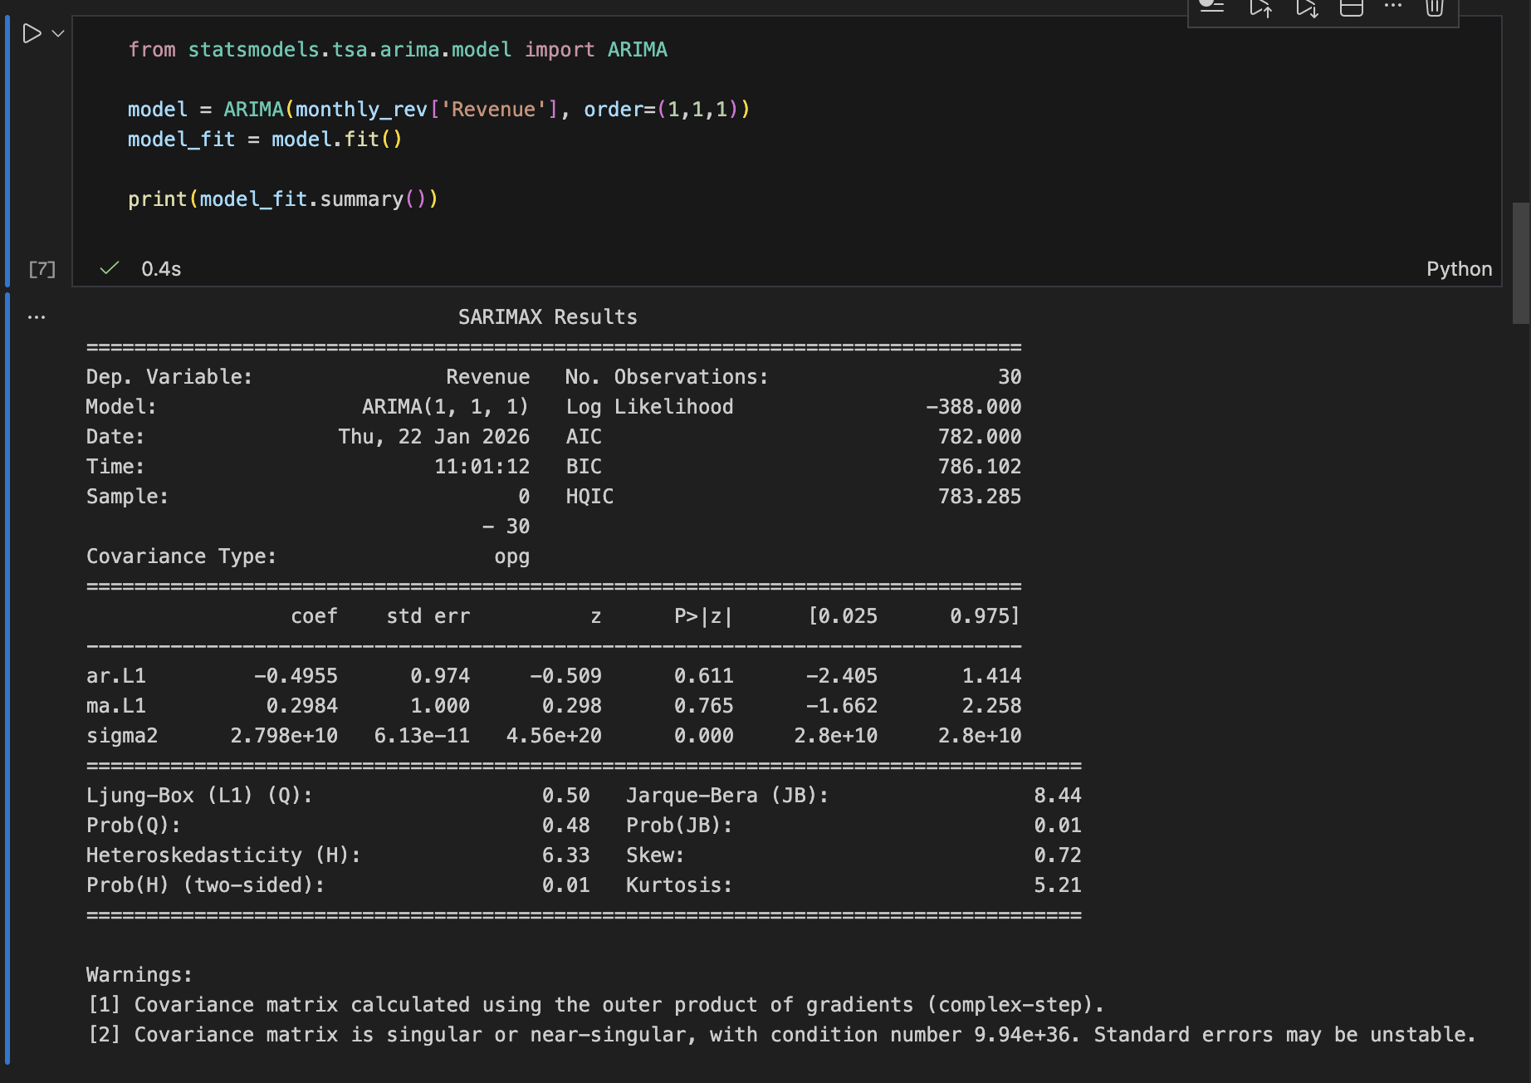

Model Summary Output

Churn Prediction:

Feature Engineering:
- Total Revenue per customer
- Total Orders
- Total Quantity
- Months since last order

Target Variable:
- Churn = 1 if inactive for more than 6 months

Model Used:
- Logistic Regression

Results:
- Accuracy ≈ 60%
- High recall for non-churn customers
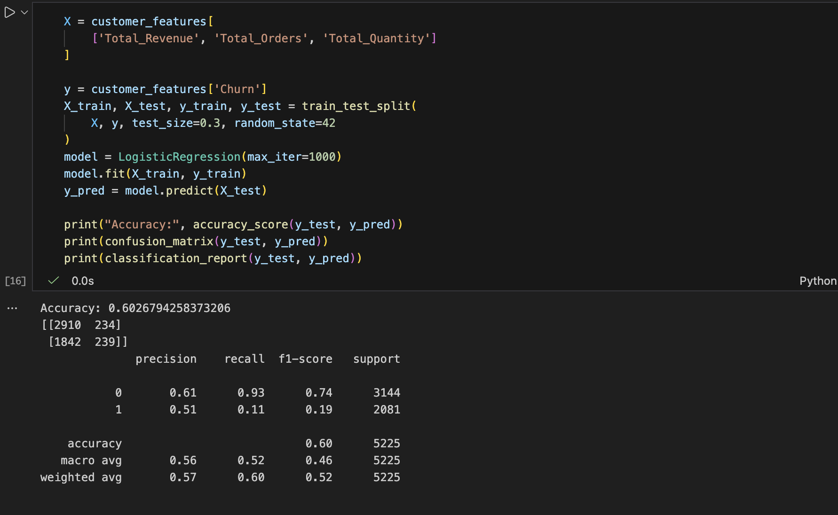
- Model highlights customers at churn risk

Churn Model Results (Accuracy, Confusion Matrix)
High Return Risk Products:

Objective:
Identify products with above-average return likelihood.

Method:
- Calculated return rate per product
- Flagged products exceeding threshold

Business Value:
- Helps reduce losses
- Supports quality control and supplier evaluation
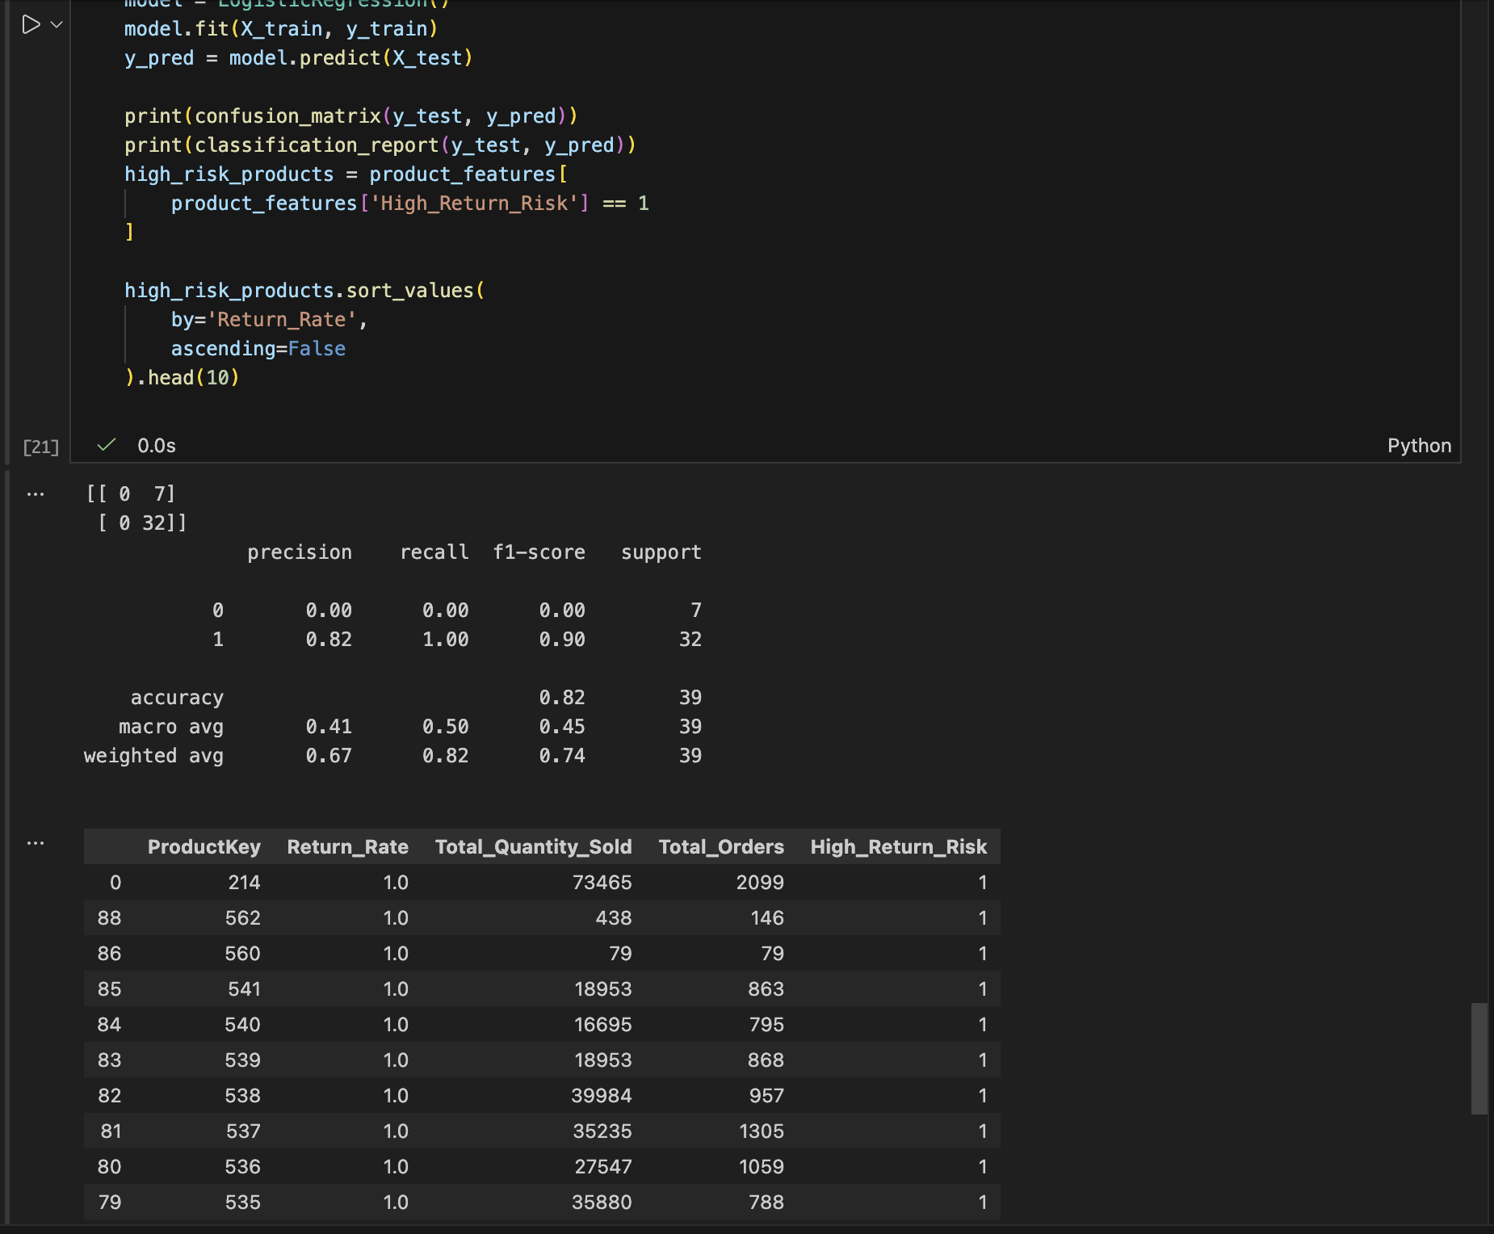
High Return Risk Products Output

6. Business Insights & Recommendations

Key Insights:
- Revenue growth peaked in 2016
- Bikes and Components dominate sales
- Certain territories yield higher profit margins
- Churn risk exists among low-frequency customers
- High return products need corrective action

Recommendations:
- Focus marketing on high-margin territories
- Improve quality checks for high-return categories
- Launch retention campaigns for churn-risk customers
- Use forecasting for inventory planning

7. Conclusion
This project demonstrates a complete analytics lifecycle:
- SQL for data integration
- Tableau for visualization and decision support
- Machine Learning for predictive insights
The solution provides actionable intelligence to improve revenue growth, customer retention, and operational efficiency.

